Implementing OMB’s New Uniform Guidance for the IHBG and ICDBG Programs
U.S. Department of Housing and Urban Development
Office of Native American Programs

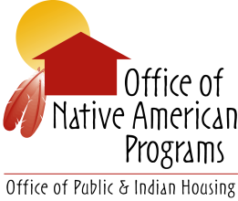

May 4-5, 2016
Phoenix, Arizona

Participant Materials

